Lab 5: PID Controller Design

*ECE 564: Fundamentals of Autonomous Robots Lab*

*Team 1: Jacob Cassady, Chase Crutcher, and Olalekan Olakitan Olowo*

*September 23, 2019*

*The group members have worked together and face-to-face at all stages of this project work. The contributions of members to the report and to the codes are equal.*

*(Initials of group members)*

# Introduction

# Lab Parts

## Primitive Wall Follow

### Quick Turn Wall Follow

#### Algorithm

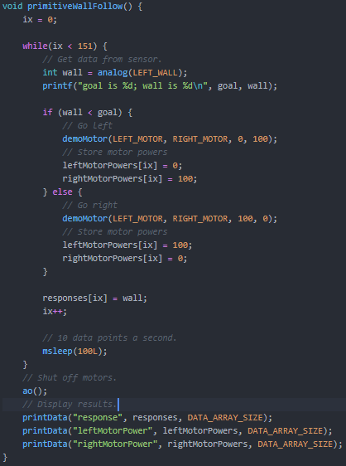

#### Experiment

#### Analysis

### Gentle Turn Wall Follow

#### Algorithm

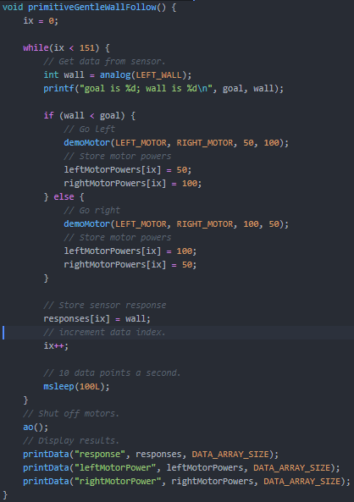

#### Experiment

#### Analysis

## Wall Following with P (Proportional) Controller Primitive Wall Follow

### Algorithm

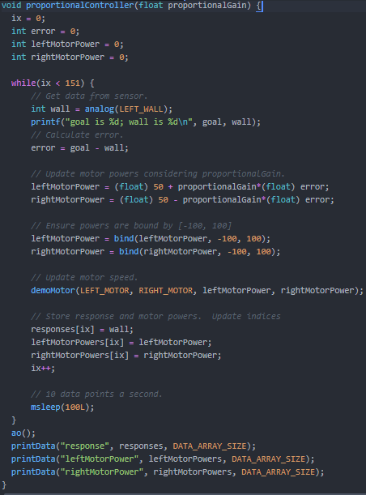

### Kp = 0.01

#### Experiment

#### Analysis

### Kp = 0.04

#### Experiment

#### Analysis

### Kp = 0.0075

#### Experiment

#### Analysis

## Wall Following with PD (Proportional and Derivative) Controller

### Algorithm

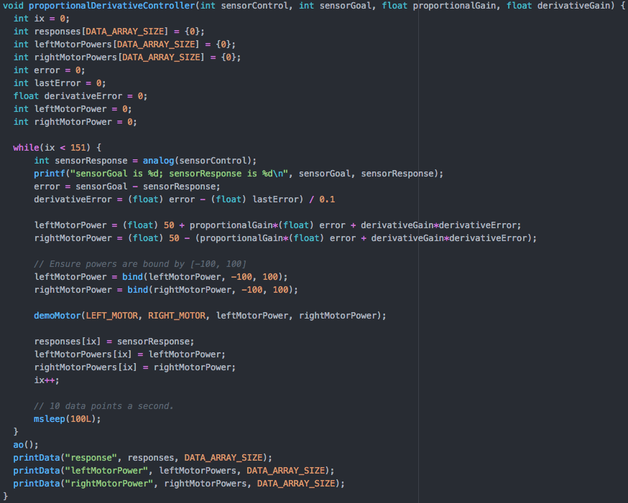

### Kp = 0.000075

#### Experiment

#### Analysis

## Wall Following with PI (Proportional and Integral) Controller

### Algorithm

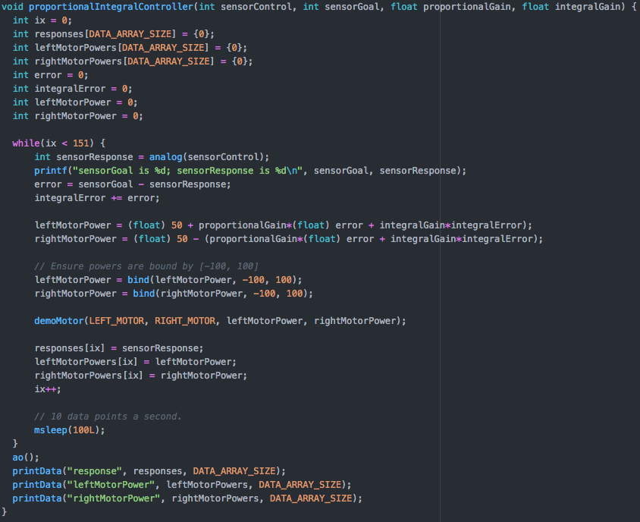

### Kp = 0.000075

## Wall Following with PID (Proportional, Integral, and Derivative) Controller

### Algorithm

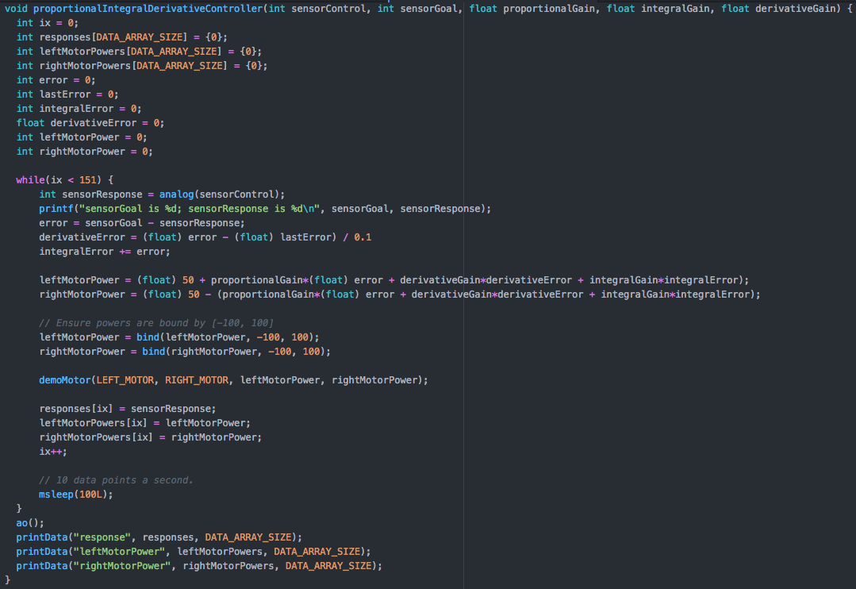

# Conclusion

# Suggestions